6YL---120型螺旋榨油机
MODEL6YL---120 SCREW OIL PRESS
一．主要性能参数:
Main Specifications
1,榨轴转速:45-55转/分
Shaft speed:45-55r/m
2,齿轮箱传动比:15/34×13/55=1:9.59
Gear ratio in gearbox: 15/34×13/55=1:9.59
3配用动力:11KW
Motor:11KW
4三角带:B型
Belt: B型
5外形尺寸:长x宽x高1820x570x1320(mm)
Outer dimension: L×W×H(mm) 1820x570x1320
6单机重量:760kg
Weight:580kg
7生产能力见表(一)
Capacity see table (1)
Table(1)production capacity

油料名称  raw material |  | 每24小时处理量(吨)  feeding per hour(t) | 每百公斤产油量(kg)Oil output per 100kg raw material | 干饼残油率(%)  residue(%)
菜籽  rape seeds | 热榨  Hot pressing | 6-7 | 30-38 | 7.5-8
菜籽  rape seeds | 冷榨  Cold pressing | 3-5 | 28-35
花生  Ground nuts | 热榨  Hot pressing | 6-7 | 35-45 | 7
花生  Ground nuts | 冷榨  Cold pressing | 3-3.5 | 32-40
大豆  Bean | 热榨  Hot pressing | 5-6 | 10-16 | 6.5-7
大豆  Bean | 冷榨  Cold pressing | .3-3.5 | 8-14
芝麻  sesame | 热榨  Hot pressing | 6-7 | 44-47 | 6.5-7.5
棉籽  Cotton seeds | 冷榨  Cold pressing | 3-4 | 10-14 | 5.5-6.5
注：以上参数是指清选，分离，轧胚辅助设备齐全，工艺合理，操作正常是能达到指标。
Note ： Figures shown above reflect performance when selecting ，separating，auxiliary facilities are available when manufacturing is rational.
二,工作原理与构造:
1,工作原理:
榨油机运转时,将处理好的料胚带如料斗,油料从料斗进入榨膛。有榨螺的螺旋向里推进，进行压榨。
因料胚在榨油机的榨膛内是在运转状态下进行的，在榨膛高压的条件下，料胚和榨膛之间产生很大的摩擦阻力。这样就能使料胚和料胚产生摩擦，造成相对的运动。另一放面，榨螺的根圆直径是逐渐增粗的，当榨螺转动时，螺纹使料胚即能向前推进又能向外翻转，同时靠近榨螺螺纹表面的料层随着榨轴转动，这样在榨膛里的每个料胚微粒都不是等速度同方向的运动。而在微粒之间也存在着相对的运动。有摩擦产生的热量又满足了榨油工艺操作上所必须的一份热量，有助于促使料胚中的蛋白质热变性，破坏了胶体，增加了塑性，同时也降低了油的粘性，容易析```````榨出油来，因而提高了榨油机的出油率。
2， Oration principle and structure
2.1 oration principle
When oil presses operating prepared material enters extruding chamber from the hopper and then moves forwards by the rotating pressing screw and is pressed. Under the high-pressure condition in the chamber ,friction between material and screw ,between material and chamber will be created ,which also creates friction and relative movement among material particles. On the other hand, root diameter of the pressing screw caries larger from one end to the other ,hence. When rotating ,it not only pushes particles moving forwards but turns them outwards as well ,meanwhile ,particles adjacent the screw will rotation along with screw’ rotating ,causing every particle inside the chamber to possess different speed. Therefore relative movement among particle creates heat which is necessary during manufacturing because of helping protein change property ,damage colloid ,increase plasticity ,decrease oil’s elasticity ,resulting in high oil productivity.
2．结构：该机有进料斗部分，齿轮箱部分，榨膛部分，榨螺部分，机架部分共五大部分组成：见图（一）

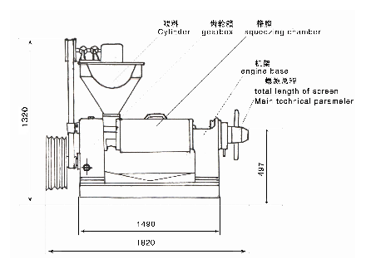
图一

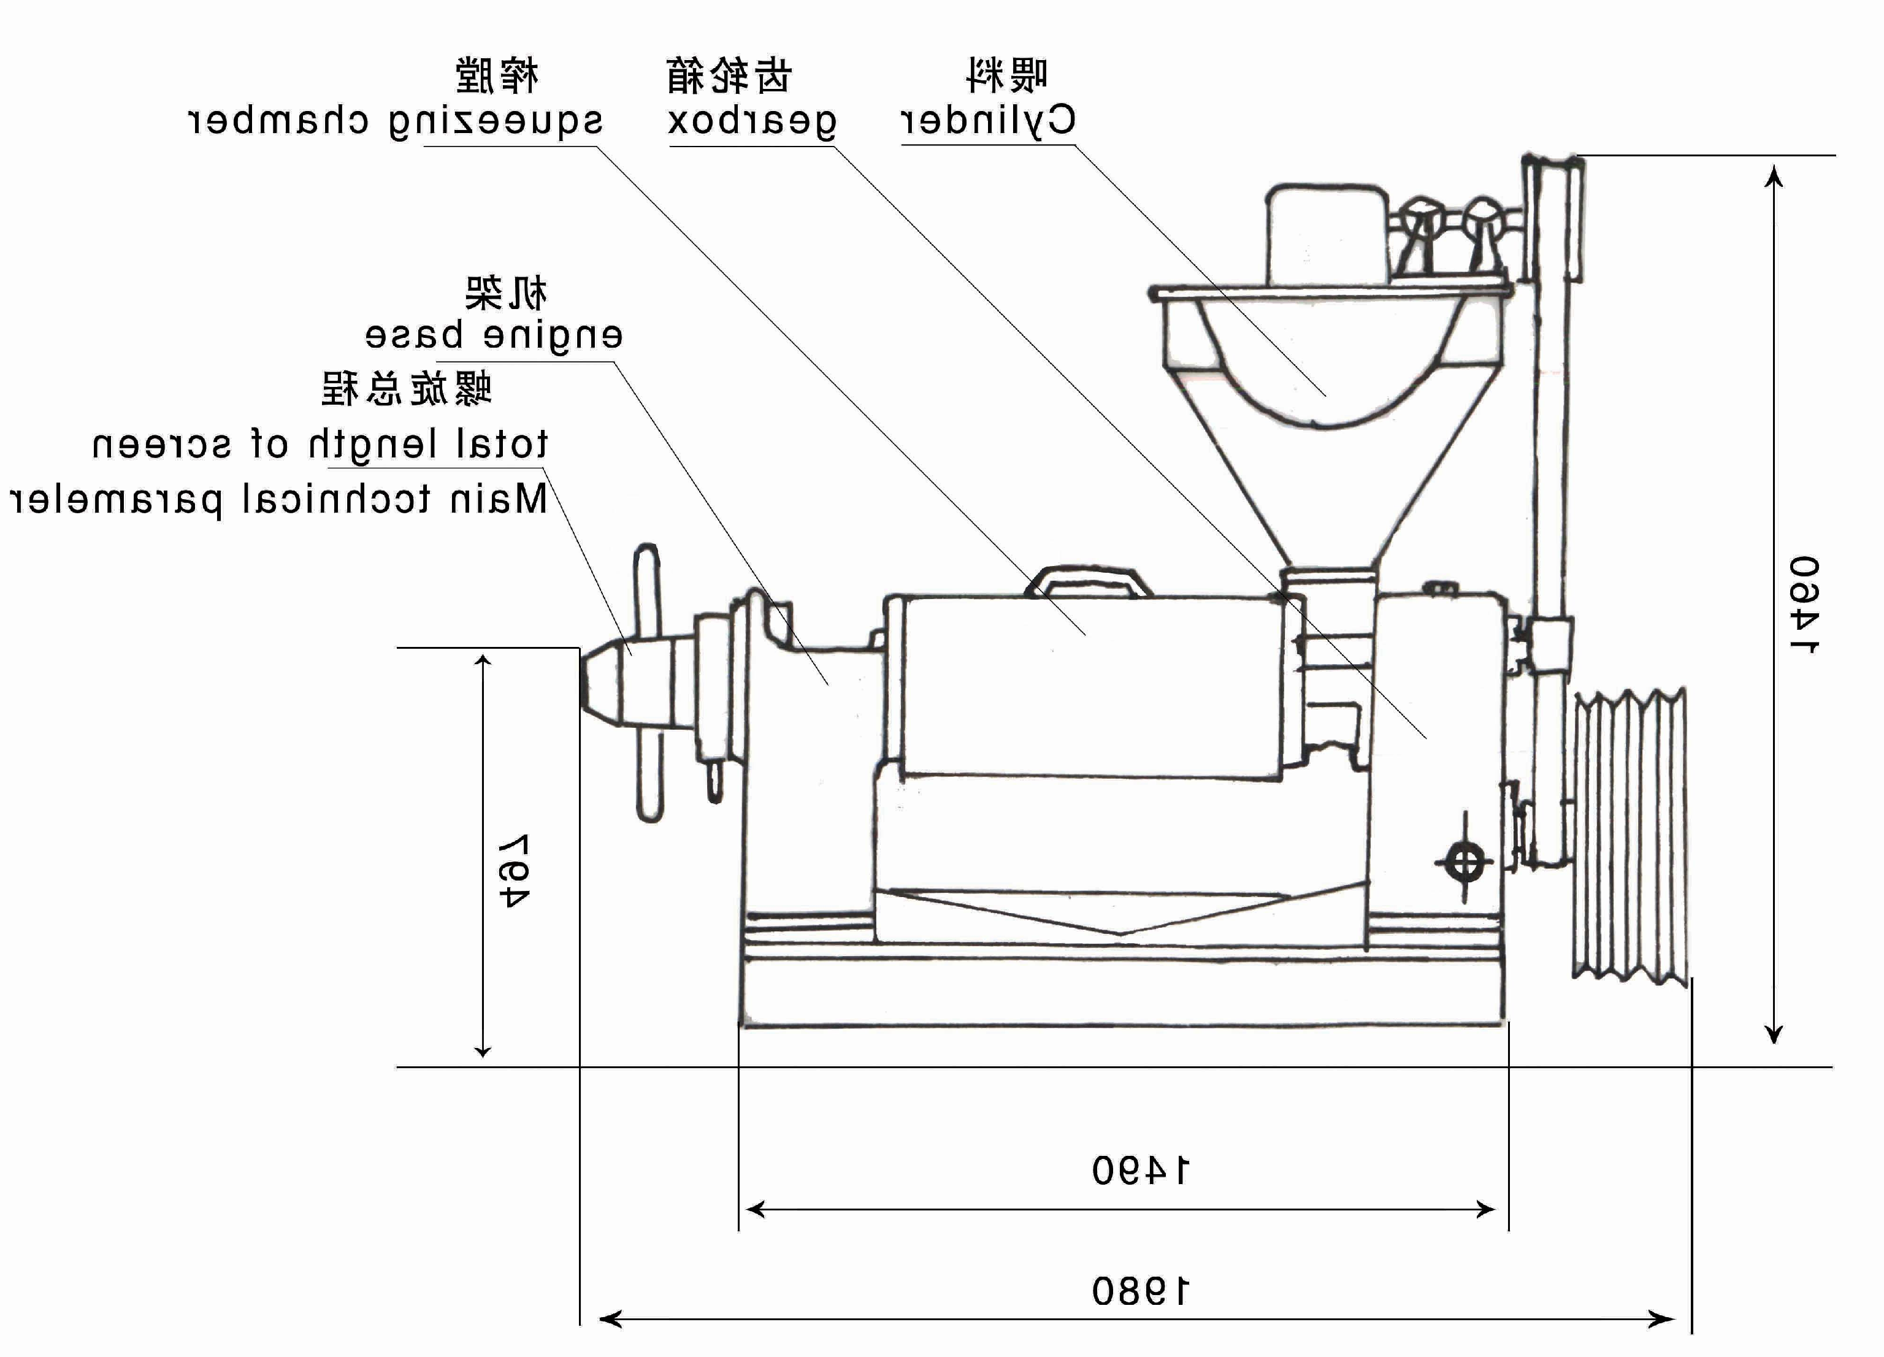
三．机器的安装：
榨油机安装时必须在地脚螺栓牢固的安装基础上，使机体保持水平。电机安在进料斗的背面。
3．Installment
The oil press must be installed by bolts firmly on the foundation and be kept horizontal
四．机器的润滑：
1．榨油机主要采用机油和黄油两种形式润滑。加油周期见表二
序号  NO | 润滑部位  lubrication | 油脂种类  lubricate | 加油周期  Time span | 换油周期  Lubricate replacement period
1 | 调节螺栓  Adjusting bolt | 20号机械油  Mechanical oil NO.20 | 每班2次  1-2time/day
2 | 伞齿轮  Bevel gear | 20号机械油Mechanical oil NO.20 | 每班2次  1-2time/day
3 | 轴承座套  Bearing bush | 20号机械油Mechanical oil NO.20 | 每班2次  1-2time/day
4 | 齿轮箱  Gearbox | 20号机械油Mechanical oil NO.20 | 首次加油12kg  First time 12kg | 六个月  Every 6 months
5 | 各滚动轴承  bearing | 润滑油  grease |  | 每年一次  Each year
4.Lubrication
4.1 Oil press is lubricated by lubricating oil and grease, see table(2)
五.机器操作:
(一)开机前的要点:
1.开机前先将齿轮箱内加注12公斤机油.
2机器安装好后,按规定加注润滑油,检查各零部件是否紧固,操作手柄,插板是否灵活.
3.用手搬动大皮带轮查机器有无松动或卡机现象,若有异常及时排除.
4.调整皮带的松紧度,启动电机,检查槽轮方向是否与标志方向一致.
5检查准备工作做好后,松开紧锁螺母把榨螺拧到死点,再退回3-4圈,再前进半圈,保证榨螺与出饼口的间隙.
5.1 preparation before operating
5.1.1 12kg of lubricant needs to be filled into the gearbox.
5.1.2 After installing the machine, check whether lubricant has been filled in, bolts have been tightened, and handles are operable.
5.1.3 Check large pulley whether it is loose or blocked ,repair it if necessary.
5.1.4 Adjust the tightness of the belt ,switch on the motor and check its rotation direction.
5.1.5 Loosen the lock nut and tighten the screw to its end, then loose it for3-4circles and then tighten it again for half circle to assure the gap of the residue cake outlet.
(二)开机:
1,启动电机,开动机器,将饼加入6%-8%水分,倒入料斗,磨光榨膛,进料不可过猛,否则可能造成榨膛堵塞与卡死机器事故,因此开始下料应该缓慢均匀,待榨膛磨光后,正常出饼后,方可将料胚倒入料斗.
2.运转后观察出饼情况,如不出饼,将榨螺再退出1-2圈,如还不出饼,应停机检查.切记杜绝开带车.故障排除后再行初榨工作.正常运转时饼厚1-2毫米,饼成瓦片状,手捏不粘,内面光滑,外面发皱,表面不带油迹.
饼厚的调节:搬动调节螺旋上的手柄,将调节螺栓顺时针旋转,螺栓往外,饼就厚,反之饼就薄了。（调节螺栓为左T165x6）出饼圈与出渣稍头的锥角不同，每转一圈较饼厚度变化为0.4-0.5毫米。
3．榨油机运转中，应经常检查出油，出渣情况，正常时油大部分从条排与前几节园排流出。如饼碎成渣，说明胚料太干。如发现饼发热（散出蒸汽）成大片状说明水分太高，应及时进行调节胚料水分的含量。
出渣：条排出渣时成细片状说明水分高，如出粉状含沫说明水分低。园排渣过多属压紧螺母未压紧圆排，应上紧压紧螺母，如水分合适，则条排不出渣或少出渣，圆排少量出渣也是允许的。料胚含水分的高低直接影响出油率，因此压榨时应控制好料胚的水分。
5.2 operation
5.2.1 Feeding must be steady and slow at the beginning to avoid blocking
5.2.2 In the case no cake is extrude outward，return back the screw for 1-2circle 。If there is still no cake is observed，machine needs to be shut down and checked ，However， in any case， operating the machine backward is absolutely prohibited normally ，cake looks like tile but not sticky ；thickness is 1-2mm ，inner side is smooth ，out side creases and no oil the surface is allowed.
Cake thickness adjustment: Rotating the adjusting handle clockwise will make the cake thicker, otherwise will make it thinner. Each circle of adjustment(by adjustment bolt left hand T 165x6)will change the thickness 0.4-0.5mm.
5.2.3When machine is operating, oil extruding and residue outlet need be checked
Frequently .Normally, most of oil will flow outward from square rods and several front round plates. Broken cake residue indicates the material is too dry ; steam emerging from the cake residue indicates that it is too wet ,In any case ,water content in the raw material must be adjusted from time to time.
Slag slice emerging indicates too much water content and power-like slag low water content .Loose round plates will cause too much slag flowing outwards. However ,adequate water content will cause slag flowing outwards from square rods, little slag from round plates is allowed. In a word ,water content affects oil output rate , it needs adjusting properly.
(三)停机:
1.正常停机应将料胚全部榨弯,反复将榨螺退进数次,将榨膛中语料 走完,将出饼放至最后,然后停车.
2.停电或因其它事故突然停车,先切断电源,抽出放料挡板, 用人力反转大皮带轮,使心轴反转时退出料胚,立即将榨螺轴推出榨膛(当人力反转大轮困难时,不得强制进行.以免损坏机器),进行清理.若抽不出来,应将压榨螺母松动,要把上榨笼拆钓,用螺丝刀逐个将圆排松动,清理,未经清理不得再行开车.
5.3 stopping
5.3.1Repeatedly move screw forwards and backwards for several times and let all material resided in the chamber goes out and adjust the cake to the possible thinnest, then stop the machine.
5.3.2 When machine stops caused by any accident, power supply must be shut down first, then rotate large pulley manually backwards, let the material return out . Then pull out the shaft and clean it. In the case the shaft could not be pulled out, remove the upper case and loose lock nut, separate round plates and clean them one by one.
六.机器的主要零部件拆,装:
1.主要零部件的拆装方法:
(!)榨笼(包括圆排、条排骨圈)的拆装方法:
旋转榨螺轴,将榨螺 从榨膛内抽出,然后用直径24毫米粗的铁棒插入出饼端压紧螺母的孔内,逆时针方向旋转松动螺母:松动上榨笼两端4个M16的连结螺钉,卸掉连结上下榨笼的12个M16的螺栓,拆去上榨笼即可将圆排圈取出。见图二
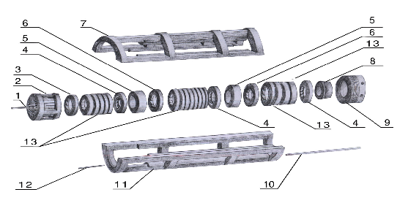

图图二

标号  Item | 零件名称  Description | 每台数量  Q’ty per set | 标号  Item | 零件名称  Description | 每台数量  Qty per set
1 | 条排  Pressing bar | 16 | 8 | 出饼圈  Cake output ring | 1
2 | 条排圈  Rails group ring | 1 | 9 | 压紧丝  Pressing bolt | 1
3 | 1＃圆排  Pressing ring NO.1 | 1 | 10 | 榨笼长键Pressing cage major key | 1
4 | 7＃18＃25＃圆排  Pressing ring NO.6、16、22 | 3 | 11 | 下榨笼  Bottom cage y | 1
5 | 8# 19＃圆排  Pressing ring NO.7 | 2 | 12 | 榨笼短键Pressing cage minor key | 1
6 | 9＃ 20＃圆排  Pressing ring NO8、18 | 2 | 13 | 2-6＃10-17＃21-24＃圆pressing ring 2-6＃10-17＃21-24＃ | 12
7 | 上榨笼  Top cage | 1
注意:记住各圆排的位置,便于装配。
(2)条排的拆装方法:
卸下条排骨圈用铁棒的一端从侧面抵住一根条排,用手敲击另一端,将一根条排打出,其余条排将自动松散下来.
(3)条排的装配方法:
将条排圈立起,代出油槽面向下(建议下面放块木板),把条排逐个的整齐的排列在内壁上。带深油槽的一端朝下，两个条排的深油槽面不能对着放在一起。最后一个条排用金属棒打入》若条排松动，可以在条排之间加铁皮，使条排紧贴内壁，达到用手摸内壁无突起现象为止。
（4）榨笼的装法：
将条排圈有出油槽面面向机架，再按圆排序号依次放入圆排。带出油槽面朝向机架。然后用压紧螺母少上几扣靠住圆排，在装上榨笼。（上下榨笼均为配对制造，如更换需上下一齐换掉）用卸下的螺栓逐个交替上紧。
6.Maintenancen and Assembly/disassembly of Main parts
6.1 Assembly/disassembly of Main parts
6.1.1 Pressing case(round plates, square rods holder)
Rotate the screw shaft and remove it from the chamber. Loose the lock nut on the outlet end by rotating it counter-clock wise using a 24 mm diameter bar, loose four M14bolts, remove ten M16 bolts which are used to connect upper and lower cases. However ,after removing upper case, round plates and square rods holder can be pulled out.
6.1.2 Remove square rods:
After removing the holder, tap the end of one rod and take it out, then others will be easily removed.
6.1.3 Assembly of rods:
Erect the rod holder vertically and make its side with oil grooves locate downwards, better on a wooden plate, then put square rods to touch holders inner wall circumferentially with their grooves downwards again. However, grooves of every two adjacent rods should not be touched. Then insert shins(by a hammer)properly into rods gap to let than firmly touch rods holders inner wall. As a matter of fact, whole inner wall of rods should be smooth.
6.1.4 Assembly of the case:
Put the groove side of rod the holder to face the machine body, then insert round plates as per marks on them. Put lock nuts on to contact plates and then mount the upper case. Tighten bolts one by one.
2.榨螺的拆装方法：见图三
（1）榨螺的拆法：停机后立即搬动手柄，把榨轴从榨膛内抽出，卸下保护帽、六方螺母、园螺母及调节螺栓，用直径16的铁棒插入锁紧螺母的孔内顺时针方向旋转（切记与轴芯配合的螺纹均为左旋），拆去紧锁螺母后，各节榨螺即可卸下。如榨螺（内孔进有细渣）因阻塞不好拆卸，可将地上垫一木板，二人将榨螺轻撞几 下即可卸下，若仍卸不下来，可用木柴火加热后再卸下。
（2）榨螺的安装：将榨螺立起细端向上，装上档圈，在把榨螺由1号起依次装于轴上，然后用锁紧螺母压紧，以防油渣深入榨螺孔内，影响榨螺的拆卸。（调节螺母使调节栓两端是8309轴承，装时两轴承大孔面均靠在调节螺栓的两端面。榨螺整体装齐后用两个（M42×2）的螺帽背紧，背紧时注意两个8309轴承的缝隙 。用手搬转调节螺栓，感到转动灵活时即可。
6．2 Pressing screw：
6．1．1 Disassembly of the screw ：rotate the handle as soon as machine stops and pull out the screw from the chamber ，remove nuts and adjusting bolt. Insert a 16mm diameter bar into lock nut and turn and turn it clockwise.(important note: left hand screw).After taking off lock nut, each part of pressing screw can be removed. However, holes in the screw might be blocked by fine slag particles, which retard the disassembly. Tapping or heating pressing screw might help disassembling.
6.1.2 Mounting pressing screw :put small end of its shaft upwards, mount the first screw and then the second...sequence, tighten then by the lock nut to avoid particles in . On both ends of adjusting bolt, which is easily swung on the shaft by adjusting nut, two bearing 8309 are mounted. Be careful to make big hole sides of these two bearings touch adjusting bolts double ends. Finally , whole pressing screw will be tightened by two M42×2 nuts, But certainly, gaps of two bearings need to be carefully set. In fact, if hands can swing adjusting bolts smoothly, the adjustment is acceptable.

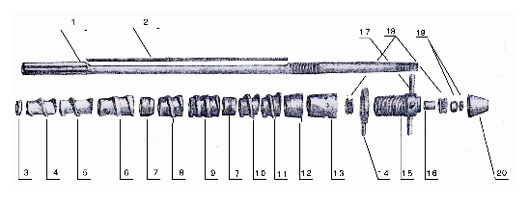图三

标号  Item | 零件名称  Description | 每台数量  Qty per set | 标号  Item | 零件名称  Description | 每台数量  Qty per set
1 | 螺旋轴  Screw shaft | 1 | 12 | 出渣稍头  Cake guide ring | 1
2 | 长键  Long flat key | 1 | 13 | 锁紧螺母  Press nut | 1
3 | 档圈  Intermediate ring | 1 | 14 | 紧定螺母  Tight nut | 1
4 | 1＃榨螺  Worm NO1. | 1 | 15 | 调节螺栓  Adjusting bolt | 1
5 | 2＃榨螺  Worm NO.2 | 1 | 16 | 含油套  Adjusting bolt bush | 2
6 | 3＃榨螺  Worm NO.3 | 1 | 17 | 大手柄  Big handle | 4
7 | 4＃榨螺  Worm NO.4 | 2 | 18 | 轴承(8309)  Bearing 8309 | 2
8 | 5＃榨螺  Worm NO.5 | 1 | 19 | 圆螺母  End nut | 2
9 | 6＃榨螺  Worm NO.6 | 1 | 20 | 保护帽  Safe cover | 1
10 | 8＃榨螺  Worm NO.8 | 1
11 | 9＃榨螺  Worm NO.9 | 1

3.齿轮部件图(图四)
6.3 structure diagram of gearbox.

图四

标号  Item | 零件名称  Description | 每台数量  Qty per set | 标号  Item | 零件名称  Description | 每台数量  Qty per set
1 | 大皮带轮  Big belt wheel | 1 | 11 | 轴承(6308)  Bearing （6308） | 1
2 | 无孔轴承盖  Gland | 3 | 12 | 长隔套  Long Spacing collar | 1
3 | 短隔套  Spacing collar | 1 | 13 | 15牙齿轮  Gear 15 teeth | 1
4 | 13牙齿轮  Long gear 13teeth | 1 | 14 | 箱体  Gearbox body | 1
5 | 大压盖  Big gland | 1 | 15 | 齿轮箱短轴  Gearing minor axis | 1
6 | 轴承(6218)  Bearing （6218） | 1 | 16 | 齿轮箱长轴  Gearing major axis | 1
7 | 55牙齿轮  Gear 55 teeth | 1 | 17 | 油封  Oil seal | 1
8 | 齿轮箱盖  Gearbox cover | 2 | 18 | 有孔压盖  Gland with hole | 1
9 | 挡圈  Striker ring | 1 | 19 | 小皮带轮  Small triangle | 1
10 | 34牙齿轮  Gear 34 teeth | 1

七. 安全生产规则:
为了保证机器的正常运转,避免机器人身事故的发生,请严格注意下列事项:
- 机器运转中,禁止用手或金属棒深入料斗内或拨弄出饼处的饼.
- 在开车前或机器运转中,严禁将榨螺拧到死点,以导致出渣稍头 和出饼圈接触,相互摩损,造成机器事故.
机器的存放:榨油机若长期停放, 应除去表面油垢,清理各油部件油渣.涂防锈油,置于干燥处,榨笼用油布盖猪,以免灰尘杂物入积条排、圆排缝隙,影响下次使用.
7. Safety
Following items are strictly requested to be obeyed.
7.1 During operating, hands or metal rods are strictly prohibited to enter the hopper to touch cakes.
7.2 Tightening the screw shaft to its dead end is prohibited before starting or during operating, which might cause slag outlet to contact cake outlet ring, resulting in wearing.
In the case of storage, oil dirt on machines surface and slags on each part need to be taken off. Paint
rust-resisting grease and keep in dry place. Case needs to be covered to prevent dirty foreign particles from entering.
八.影响出油的主要因素:
影响螺旋榨油机出油率的主要因素有一下几点:
- 油料的水分:
影响出油率最关键的因素是油料的水分,油料中水分多或少都直接影响出油率.一般用户没有化验设备,几种主要油料的合适水分可按经验方法确定如下:
(1). 大豆: 如果用门牙咬能咬碎, 用臼牙咬成扁谝状, 具有裂纹, 有轻度的响声, 则说明水分 合适.若成扁片状, 但没有裂痕, 则太湿; 可用火炕或太阳晒的方法进行处理. 若破碎并有很大的响声,则太干;这时需要适量的水.
(2) 棉籽:用牙咬壳仁分离,壳破有响声,则合适;若成扁形,则太湿。若壳仁成粉，则太干。
（3）菜籽：可用两种方法分榨：冷榨或热榨。
冷榨时：用指甲挤有响声，分成两片并有油挤出，为合适；成粉则太干，成粉则太湿。
热榨时：需经炒，炒后检查，用两块木板揉擦菜籽，壳与仁分离则合适：若仁成粉则太干；若壳与仁不分则太湿。
2． 出饼的薄厚，反映出榨膛的压力大小；饼厚则压力小，饼薄则压力大。一般规律与圆排的松紧相似，即油料含油少压力就应大，饼薄，圆排应压紧（用压紧螺母压紧）；油料含油多，则榨膛压力应小，饼厚，圆排应松些。
饼比较合适的厚度为：
大豆： 第一遍压榨应稍厚为1-1.5毫米左右：第二遍的厚应为0.5-1毫米左右。
棉籽：榨一遍即可，饼厚在1-2毫米左右。
花生仁：一般冷榨2-3遍，饼厚1-2毫米左右。
在榨油中，由于各种因素的不同，因此掌握出饼的厚度应根据出饼的情况，出油最旺时为合适饼厚。对上述饼厚度的确定数字决不能生搬厚度应根据出饼的情况，出油最旺时为合适饼厚。对上述饼厚度的确定数字决不能生搬硬套。
8． Factors affecting oil output rate
Following factors may affect oil output rate：
8．1 Water content：This is the critical factor，as a matter of fact ，water content directly affects oil output rate
However, user usually has not proper inspection equipment. Hence, water content of some main raw material may be detected as follows:
8.1.1 Bean: if teeth beating could crack it, forming flat pieces accompanied with light sound , the water content is suitable. Flat piece without cracking means too wet. Heating or sunshine may be drive water off. However, cracking accompanied with loud indicates too dry. Adequate water needs to be added.
8.1.2 Cotton seeds: shell and kernel may be separated by teeth beating. Shell breaking may be accompanied by sound, which means water content is suitable .shell being flatting indicates too wet, shell being splitted into powder means too dry.
8.1.3 Rape seeds: They can be pressed either at hot or at cold state.
Cold pressing: extruding by finger, if they splitted into two pieces, accompanied by sound and oil, this implicates water content is adequate. Otherwise, extruding makes power indicates too dry; makes flat slice, too wet.
Hot pressing (after heating) : To scratch seeds by two slices of wood, if shell and kernel could be splitted, water content is adequate. If kernel becomes power, it is too dry; in the case that shell and can be splitted, it is too wet.
  - Cakes thickness reflects the pressure inside the chamber. Thicker cake indicates lower pressure inside the chamber; thinner cake-higher pressure inside. If raw material has less oil content, chamber pressure should be higher, cake will be thinner, round plates need to be tightened; in the case of high oil content material, pressure in the chamber should be lower, then circular plates need to be loosened, resulting in thicker cake. Recommended thickness of cakes will be.
Bean: 1.1-1.5mm for the first pressing ;0.5-1mm for the second pressing.
Cotton seeds : only one pressing , 1-2mm.
Ground nut kernel : Normally cold pressing for 2-3 times , 1-2mm
Important note: cakes thickness should be as according to different factors to achieve highest oil output rate. Hence, above figures will only be for reference.
九．一般故障及其排除方法
9. failures and removal

序号 | 故障 | 产生原因 | 排除方法
1 | 突然停车，榨螺轴卡死。 | - 新机初榨，没通过磨合大量投料入榨。  - 饼的厚度太薄，榨膛压力增大。 | 1．按说明方法操作，经常注意机器的声音及电流强度的大小。
2 | 出油过底 | - 油料水分不合适。  - 榨膛温度 低。  - 条排，圆排间隙不符合要求。  - 零件磨损。 | - 按说明书操作。  - 松或紧动压紧螺母，使其少量出渣，流油畅通。
3 | 入料斗存油（返油） | 1．圆排条排过紧。  2．油料含油过多，饼出的太薄。 | 1．松动压紧螺母使其流油畅通。  2．调节出饼厚度，将饼加入榨膛把油冲出。
4 | 饼代油斑 | - 油料水分过多。  - 圆排间隙过小。  - 零件磨损。 | - 按说明书操作。  - 松动压紧螺母加大圆排间隙。  - 更换新零件。
5 | 油质暗褐而绸 | - 榨膛温度低。  - 油料杂质过多。  - 油料过干或发霉。 | - 按说明书操作  - 筛选油料。
6 | 产量低 | - 压榨未经脱绒的棉籽，绒长易于搭桥，缠轴。  - 榨膛，榨螺不光滑。  - 油料含水分过多。  - 出饼口间隙过小。  - 棕螺磨损。 | - 棉籽脱绒或经筛选。  - 在更换新件后要进行一段时间的磨合使榨螺光滑。  - 按说明书操作。  - 更换新零件。
7 | 不入料 | - 含油多的油料返油。  - 油料太湿（尤其是棉籽） | - 按说明书操作。  - 棉籽要脱绒。
8 | 严重冒渣 | - 条排，圆排间隙过大。  - 榨膛压力过大。  - 零件磨损。  - 油料太干。 | - 按说明书操作。  - 更换新件。

NO | Failures | Reasons | Removal
1 | Sudden stop, shaft blocked | - New machine without running up.  - Cake too thick, pressure too high. | 1.Carefully operating as per the manual.  2.Note motor sound and current value
2 | Low oil output | - Non-adequate water content.  - Low chamber temperature.  - Non-adequate gap among rods or plates.  - Parts worn. | 1.Operating as per the manual.  2.Loosen tightening nut to drive slag off.  3.Replace worn parts.
3 | Oil return to hopper | - Too tight rods and plates.  - high oil content and thicker cake. | 1.Loosen tightening nut。  2.Adjust cake thickness and add cakes into chamber to drive oil off
4 | Oil spot on cakes | - Too much water content .  - Too small gap among rods and plates.  - Parts worn | 1.Operating as per the manual  2.Loose tightening nut.  3.Replace worn parts
5 | Dark and viscous oil | - Low chamber temperature.  - Too much forming particles in oil .  - Raw material too dry. | 1.Operating as per manual  2.Selecting raw material
6 | Low productivity | - Poor quality of cotton seeds.  - Chamber and pressing screw not smooth.  - Raw material too much water content .  - Too much gap at oil outlet port.  - Worn screw | 1.Cotton seeds selected.  2.Make chamber and screw and smooth.  3.operating as per manual  4.replace worn parts
7 | Raw material can be fed | - Oil returns to hopper.  - Wet raw material . | 1.operating as per manual  2.cotton seeds prepared
8 | Cracked residue appears at the outlet severely | - Gaps among rods and plates too big  - Too high pressure in the chamber.  - Parts worn.  - Raw material too dry. | 1.operating as per manual  2.replace worn parts

十.主要油料的压榨方法:
1. 大豆的压榨方法:目前大豆的压榨方法主要有两种,分热榨或冷榨.
(一)冷榨工艺流程:
大豆----筛选----压榨(水分合适)
(二)热榨工艺流程:
大豆----筛选---轧胚----蒸炒----压榨
生产工艺说明: 先将大豆筛选除杂,再将大豆破碎加水约7-8%进行软化,进入蒸锅蒸至115度左右方可入榨.
2.菜籽的压榨方法:菜籽分冷榨或热榨,为了提高出油率和油品的质量,一般以热榨为主.
其工艺流程如下:
冷榨: 筛选----轧胚----压榨
热榨: 筛选----轧胚----蒸炒-----压榨
冷榨: 先将菜籽筛选去杂,再检查菜籽的含水量,无检查设备的前提下可以用土法检查:用指甲将菜籽挤一下,若有响声,并分成两片,或有油挤出最为合适,若成粉则太干,若成饼则太湿.若太干要加2.5-3%的水,待炒籽达到棕黄色,温度110-120度最为合适,方可入榨.
- 花生仁的压榨方法: 花生仁热榨或冷榨均可,以热榨为主(冷榨效果不如热榨). 热榨时先把花生仁粉碎或榨胚,然后放在蒸锅内蒸1.5-2小时,温度达120度左右,含水3%左右,即可入榨,榨油机温度达85度时,开始正常压在榨如 无蒸锅，也可将花生仁放在炒锅内炒，先将花生仁粉碎，逐渐加大约7-8%的水，炒至深黄色时，即可出锅入榨。
- 带壳花生的压榨方法：带壳花生的压榨，花生干湿必须合适，一般剥去花生的外壳，花生仁可以用手搓去红皮压榨，花生压榨两遍即可，花生过湿，压榨时产生响声，应将花生重新烘干或晒干。如榨带壳花生出饼不顺利，加大约20%的饼与花生半均后再入榨。

10．Extruding methods of several raw material.
10.1 Bean : two ways , cold and hot extruding.
(1) Cold extruding :bean-selecting-pressing (in case of adequate water content).
(2) Hot extruding : bean-selecting-per-pressing-heating(steaming etc)-pressing.
Firstly, selecting beans and remove foreign particles, then soften by breaking and adding water of 7-8%,and then steam them to 115C; beans will be ready for extruded.
10.2 Rape seeds: also, cold and hot extruding for your choice, but normally hot extruding is recommended.
Cold extruding : selecting –pre-pressing.
Hot extruding: selecting –pre –pressing-heating(steaming etc)-pressing.
When hot extrusion, to remove foreign particles by selection ,then check water content as described above; in case of too dry, add 2.5-3% of water. Normally two times extruding is enough.
When cold extrusion, after selecting , to pre-press and heat them, During heating, add2-3%of water and await till look coffee color and temperature 110-120C, then ready for pressing.

10.3 Groundnuts kernel, cold and hot extrusion are both available ,yet prefer hot pressing. When hot pressing ,firstly crack or pre-press, then steam for 1.5-2 hours, temperature about 120C.water content 3%will be good. Normal pressing starts at temperature of 85C. or crack them firstly and at a pot, add 7-8%
of water, look coffee color will be ready for pressing.
10.4 Groundnuts: remove shell first and remove red peel of the kernel ,then press for two times, Sound indicates it is too wet and need drying. In the case of poor cake moving out, mix about 20%of with them may help.

